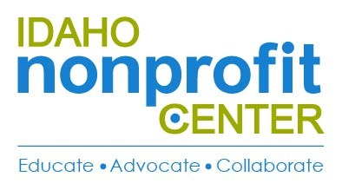
2018 – 2020 Policy Agenda, Idaho Nonprofit Center
Statement of Purpose
The Idaho Nonprofit Center Public Policy Program is intended to increase the ability of nonprofit organizations in Idaho to improve the lives of their constituents through taking action on issues of public policy that affect the nonprofit sector as a whole.
Charitable Deductions
The Idaho Nonprofit Center recognizes the importance of charitable giving, in order to improve the lives of our citizens as well as make a generous impact in the community that the nonprofit sector strives to achieve. In addition to the financial contributions that are made to community benefit organizations, we understand that volunteers fuel the work that we do each and every day, and without them, we couldn’t fulfill the mission, vision, and values we are so passionate about.

Policy Awareness & Advocacy Education
The Idaho Nonprofit Center encourages promoting civic engagement, creating a substantial voice in the community, and empowering citizens to make the change they want to see. We hope to build a unified voice for the sector with which to inform and persuade decision makers as well as encourage nonprofits to advocate in the public arena. We strive to provide them with the skills needed to do so.

Federal Budget
The Idaho Nonprofit Sector monitors what happens on a federal level as well as state level. We provide a conduit of information from our membership to state legislators and hold them accountable to the sector’s needs and concerns.

Idaho State Budget
Your state, your voice. At the Idaho Nonprofit Center, we generate community awareness of state tax dollars usage, how our elected officials are supporting the community, and what we hope to see for future generations. Together we make a stronger Idaho.

Nonprofit Capacity Building - Job Creation, and Economic Development
The nonprofit sector offers a wide variety of ways for the community to get involved as well as shape our state. The nonprofit sector is a vital part of the economy, and the Idaho Nonprofit Center looks to encourage job creation within the sector, as well as help inform citizens about creating sustainable economic development within Idaho.

